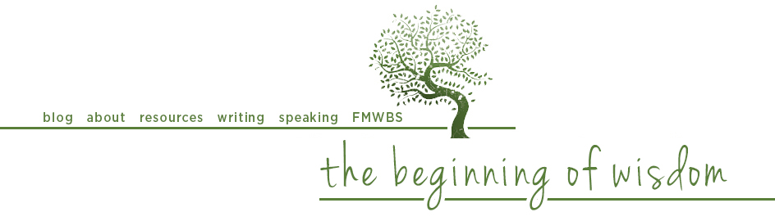

the mother of all swear words
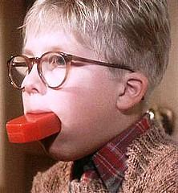
When I was in the first grade I noticed an unfamiliar word scrawled on the bathroom wall, so I went home and looked it up in the dictionary. I'm not sure how I knew not to ask my mother what it meant, but after reading its definition, my gut instinct was validated: here was forbidden stuff, with a capital F, if you know what I mean. There was no way my mom knew that word. Thank heaven for Merriam-Webster.

Twenty five years later I had a first-grader of my own. Jeff and I decided to take a different approach with “dirty words” - we decided to attack them head-on. So one day after school I casually asked our oldest child, “What bad words are the kids using at school?” He hesitated for a second and then said, “The “S-” word,” a look of anxiety on his face. “What’s the “S-” word?” I asked, hoping I could cover my own rising panic.

“I can’t say it.”

“Sure you can. You can say it to me. “

Another pause, and then, whispered: “Stupid.”

Aha. Well, that wasn’t so bad. I explained to him that Mom and Dad knew all of the “bad words” already, and that he could always come ask us what they meant. And so it went for most of elementary school – me asking about the newest words, him responding, me supplying age-appropriate definitions, both of us giggling ourselves silly over the newest addition to the grade school potty-mouth menu. Soon he brought home the “Sh-” word, which turned out to be “Shut up” initially. Then it was the “D-” word, the “Cr-” word, and then naturally the real “Sh-” word emerged not long after.

Things moved onward from there in a predictable manner – the words (and their various combinations) continued to worsen, my son continued to grow more comfortable telling me his latest discoveries, and I continued offering definitions before Merriam-Webster ever needed to be consulted. We talked about the power of “bad words”, about who was saying them and why they might say them, about what they meant, and why he didn’t hear us use them in our home. We basically diffused them of their forbiddenness by speaking them aloud to each other, giving them definitions, and talking about why they were dumb to use.

exponential expletive expansion

Around middle school, the well of depraved language began to run dry. Sure, my son’s peers were just hitting their stride from a fluency standpoint, but the number of new expletives being introduced into the lunchroom vernacular experienced a sharp drop. My son expressed the confident belief that he had learned all the bad words that there were. I informed him that he had not, that he had yet to learn the Mother of All Swear Words. He tried to get me to volunteer it, but I refused. I told him I would let him know when he had finally discovered it.

There ensued several comical years in which he brought home words and phrases like a cat proudly bearing a freakish, radioactive mouse, each time to be told, “Nice try, but that’s not the Mother of All Swear Words.” He didn’t know whether to be disappointed or proud each time he met with failure. At last he struck profanity gold, which led immediately to an excellent discussion about the objectification of women. And that’s all I’m going to say about the Mother of All Swear Words.

beating google to the punch

Why should you care about being the first word on “bad words” with your child? There are many good reasons, but consider this one: When your first-grader sees a word written on the bathroom wall and suspects you might disapprove of it, he will not look it up in the dictionary. He will Google it. And because his language skills are just developing, he will most likely go to Google Images. What do you think he will find? Or more to the point, what do you think will find him?

In order to guard your child from acting on natural curiosity in a potentially harmful way, you must become the fountainhead of “forbidden knowledge”, starting with swear words and progressing to sex. You want to be the go-to when your child has a question. Don’t ask an internet filter service to be your first line of defense – attack the problem at its root by inviting your child into dialogue early and often about their questions concerning the forbidden, the embarrassing, the secret. Invite them to trust you as the most reliable and safe search engine they can consult when their curiosity on any topic is piqued.

In short, you must become the mother (or father) of all swear words, the parent of every taboo lunchroom subject, and you must do so early. It is both your right and your duty to be your child’s first word on all things scandalous. How will you start the conversation? Delaying to do so would be nothing short of - well, the “S-” word.

http://jenwilkin.blogspot.com

